SCHOOL OF COMPUTER SCIENCE AND ARTIFICIAL INTELLIGENCE |  |  |  |  | DEPARTMENT OF COMPUTER SCIENCE ENGINEERING
Program Name: B. Tech |  |  |  | Assignment Type: Lab |  |  | Academic Year:2025-2026
Course Coordinator Name |  |  |  | Venkataramana Veeramsetty
Instructor(s) Name
  Dr. V. Venkataramana (Co-ordinator)
  Dr. T. Sampath Kumar
  Dr. Pramoda Patro
  Dr. Brij Kishor Tiwari
  Dr.J.Ravichander
  Dr. Mohammand Ali Shaik
  Dr. Anirodh Kumar
  Mr. S.Naresh Kumar
  Dr. RAJESH VELPULA
  Mr. Kundhan Kumar
  Ms. Ch.Rajitha
  Mr. M Prakash
  Mr. B.Raju
  Intern 1 (Dharma teja)
  Intern 2 (Sai Prasad)
  Intern 3 (Sowmya)
  NS_2 ( Mounika)
Course Code |  |  | 24CS002PC215 | Course Title |  | AI Assisted Coding
Year/Sem |  |  | II/I | Regulation |  | R24
Date and Day  of Assignment |  |  | Week10 - Thursday | Time(s)
Duration |  |  | 2 Hours | Applicable to  Batches
AssignmentNumber:19.4(Present assignment number)/24(Total number of assignments)
 | Q.No. | Question |  |  |  |  |  | Expected Time  to complete
 | 1 | Lab 19 – Code Translation: Converting Between Programming Languages  Lab Objectives:  - Understand how AI tools can assist in translating code between different programming languages.  - Learn to verify correctness and functionality after translation.  - Explore syntactic and semantic differences between languages (e.g., Python, Java, C++).  - Practice debugging and optimizing AI-translated code.  Task 1: Translate a Simple Program (Python → JavaScript)  - Instructions:  - Write a Python function print_numbers() that prints the first 10 natural numbers using a loop.  - Translate the function into JavaScript as a reusable function printNumbers().  - Call the function in both languages to display results.  - Expected Output:  - 1  - 2  - 3  - ...10  Prompt:  Write a program to Print first 10 natural numbers in both Python and JavaScript  Code:  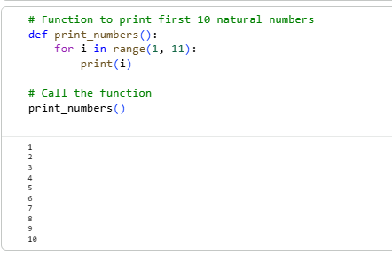  JS CODE:  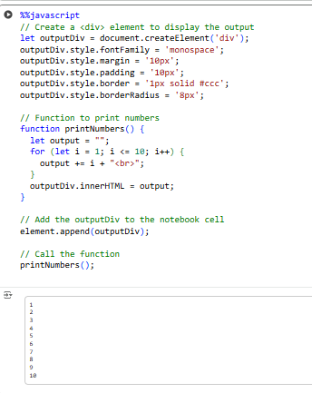  Task 2: Convert Conditional Statements (Java → Python)  - Instructions:  - Write a Java method checkNumber(int num) that checks if a number is positive, negative, or zero.  - Translate the method into a Python function check_number(num).  - Call the function/method with different inputs and compare outputs.  - Expected Output:  - Input: -5 → Output: The number is negative  - Input: 0 → Output: The number is zero  - Input: 7 → Output: The number is positive  Prompt:  Write programs in Java and Python to check if a number is positive, negative, or zero,using a function or method (checkNumber / check_number)  JS CODE:  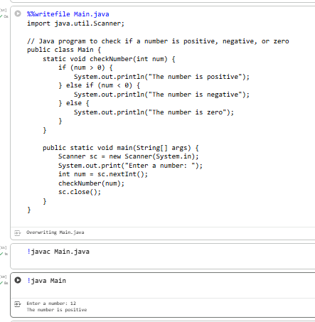  PYTHON CODE  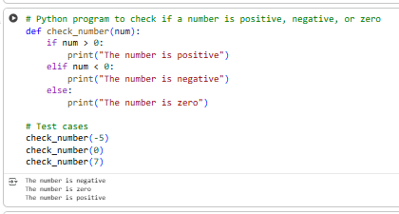  Task 3: Translate Recursive Function (Python → C++)  - Instructions:  - Write a Python function factorial(n) that calculates factorial of a number using recursion.  - Translate the same into a C++ function int factorial(int n).  - Call the function in both languages with inputs 5 and 0.  - Expected Output:  - Input: 5 → Output: Factorial = 120  - Input: 0 → Output: Factorial = 1  Prompt:  Write programs in Python and C++ to calculate the factorial of a number using recursion.Define a function (factorial).  PYTHON CODE:  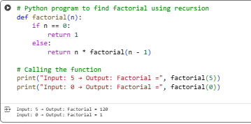  .C++ CODE:  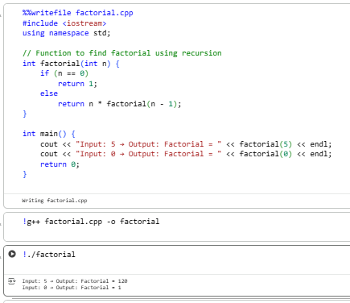  Task 4: Data Structures with Functions (JavaScript → Python)  - Instructions:  - Write a JavaScript function printStudents(students) that takes an array of student names and prints each name.  - Translate it into a Python function print_students(students) using a list.  - Test both functions with sample student names.  - Expected Output:  - Student List:  - Alice  - Bob  - Charlie  PROMPT:  Write a JavaScript function printStudents(students) that takes an array of student names and prints each name. •Translate it into a Python function print_students(students) using a list.  JSCODE: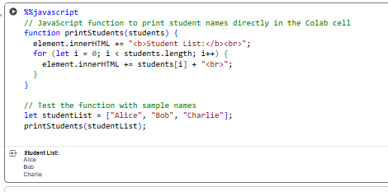 PYTHON CODE:  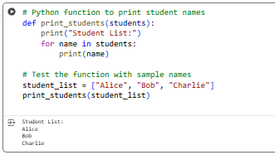  Task 5: Class & Object Translation (Python → Java)  - Instructions:  - Write a Python class Car with attributes: brand, model, year.  - Add a method display_details() that prints car details.  - Translate the same into a Java class Car with attributes and a method displayDetails().  - Create an object in both languages and call the method.  - Expected Output:  - Car Details:  - Brand: Toyota  - Model: Corolla  Year: 2020  PROMPT:  Write a Python class Car with attributes: brand, model, year.Add a method display_details() that prints car details. Translate the same into a Java class Car with attributes and a method displayDetails().  PYTHON CODE:  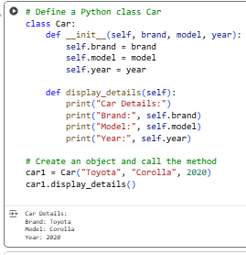  JS CODE:  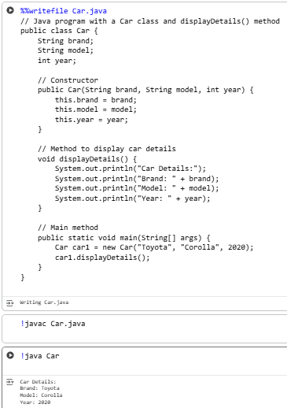  ✅ Deliverables (For All Tasks)  - AI-generated prompts for code and test case generation.  - At least 3 assert test cases for each task.  - AI-generated initial code and execution screenshots.  - Analysis of whether code passes all tests.  - Improved final version with inline comments and explanation.  - Compiled report (Word/PDF) with prompts, test cases, assertions, code, and output. |  |  |  |  |  | Week10 - Thursday

